* Background color of navigation bar:

**File -** menupack-responsive.css (Line No. -149)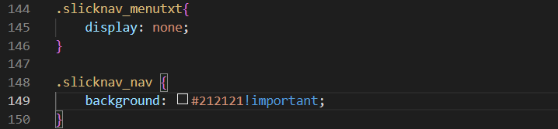

Note:- Don’t remove “!important”

* Text color of navigation bar:

**File -** menupack-responsive.css (Line No. -152)

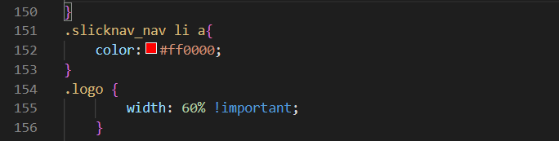

* Text and background color on hover effect:

**File -** menupack-responsive.css (Line No. – 159-165)

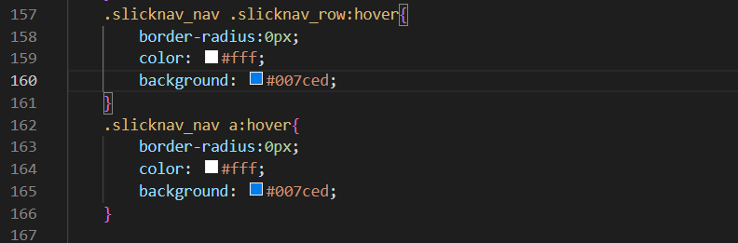

Text color

Background color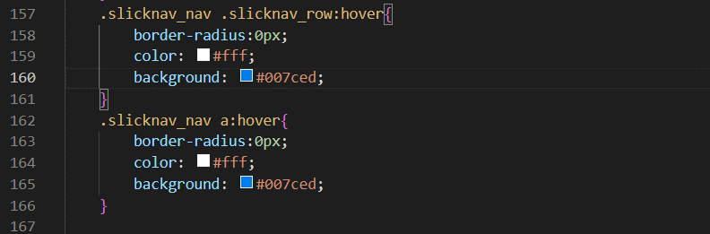

* Color of header:

**File -** menupack-style.css(Line No. - 2489)



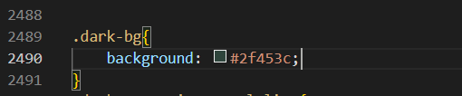

* Color of lines:

**File -** menupack-style.css(Line No. – 2168,2180)



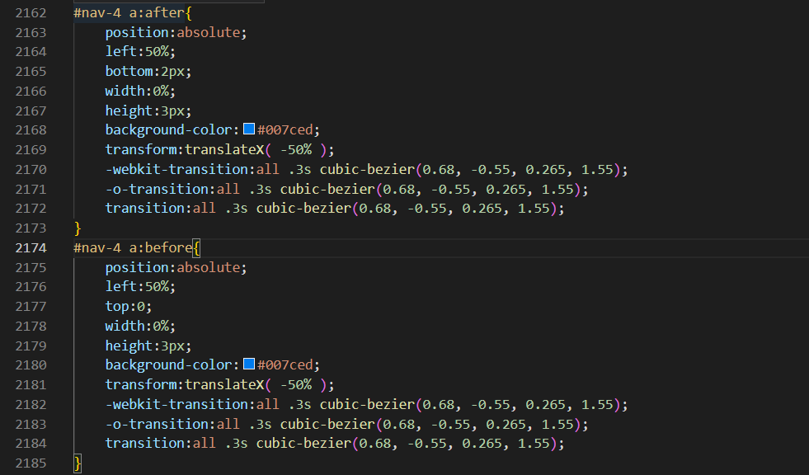

* Color of Upper-Border:

**File -** menupack-style.css(Line No. – 1362)

